PRF Day 02 Assignment

Question 01
class Question01{
public static void main(String [] args){
System.out.println("Githmi Thathsarani");
System.out.println("Near the 4th mile post,Bombuwala");
System.out.println("0762895678");
System.out.println("GithmiqweThathsarani@gmail.com");
}
}
Question 02
class Question02{
public static void main(String args []){
int row = 7;
for (int i=0; i<=7; i++){
for (int j=0; j<=i; j++){
System.out.print("*");
}
System.out.println();
}
}
}
Question 03
import java.util.*;
class Question03{
public static void main(String args[]){
Scanner input = new Scanner(System.in);

int A;
int B;

System.out.print("Enter Value(A): ");
A = input.nextInt();
System.out.print("Enter Value(B): ");
B = input.nextInt();

System.out.println();

System.out.println(" " + A);
System.out.println("+ " + B);
System.out.println("--------------");
System.out.println(" "+A + B);
System.out.println("==============");

input.close();

}
}
Question 04
class Question04{
public static void main(String [] args){
System.out.println("******========================");
System.out.println(" ******=======================");
System.out.println("******========================");
System.out.println(" ******=======================");
System.out.println("******========================");
System.out.println(" ******=======================");
System.out.println("******========================");
System.out.println(" ******=======================");
}
}
Question 05
A
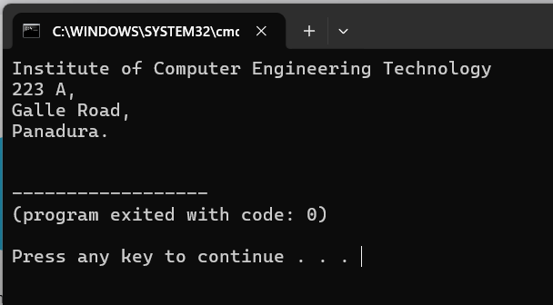
B
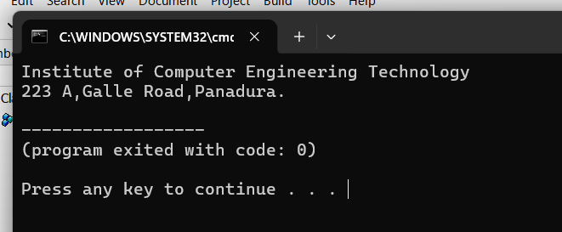
Question 06
print() :- print the one row
println() :- next move the new row
Question 07
“a” :- Print the a
‘a’ :- Print the a value
Question 08
Line 1 :- int
Line 2 :- double
Line 3 :- string
Line 4 :- char

Question 09
- String Literls
- “Hello!”
- Inteher Literls
- Decimal - 100
- Octal - 0177
- Binary – ob100101
- Hexadecimal – ox64

- Floating Point Literls
- 55.34
- Cherecter Literls
- ‘A’
- Boolean Literls
- True,false
- Null Literls
- null
- Long Literls
- 78952553L
- Floating Point Literls
- 2.5f
Question 10
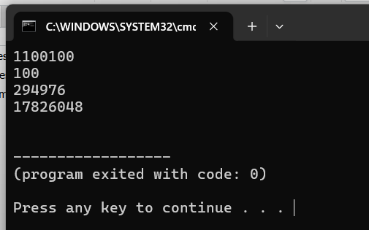
Line 1 :- decimal
Line 2 :- binary
Line 3 :- Octal
Line 4 :- Hexadecimal
Question 11
Line 1 :- valid
Line 2 :- valid
Line 3 :- invalid(1 or 0 only)
Line 4 :- valid
Line 5 :- valid (0-7)
Line 6 :- valid
Line 7 :- valid
Line 8 :- invalid (0-9, A-F,a-f)
Line 9 :- invalid
Line 10 :- valid
Question 12
Compile error
Question 13
class Question13{
public static void main(String args[]){
System.out.println ("i. iCM – iCET CERTIFIED MASTER");
System.out.println ();
System.out.println ("ii. iCM ");
System.out.println ();
System.out.println (" iCET ");
System.out.println (" CERTIFIED ");
System.out.println (" MASTER ");
System.out.println ();
System.out.println ();
System.out.println ("iii. iCM ");
System.out.println ();
System.out.println (" ICET CERTIFIED MASTER ");
}
}
Question 14
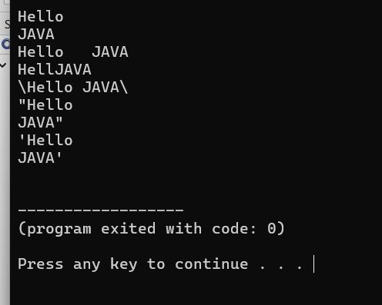
Question 15
class Question15 {
public static void main(String args[]){
System.out.println("a. Java is a typed language");
System.out.println("b. AB \" CB");
System.out.println("c. AB\\CD");
System.out.println("d. C:\\Windows\\Program");
System.out.println("e. AB\\\"CD");
System.out.println("f. AB\\\\\"\"CD");
System.out.println("g. AB\\nCD");
System.out.println("h. AB\\tCD");
System.out.println("i. AB\\bCD");
}
}
Question 16
class Question16{
public static void main(String args[]){
System.out.println(" _ _____ _____ ______ ");
System.out.println("(_)/ ___| ___|__ __|");
System.out.println(" _| | | |__ | | ");
System.out.println("| | | | __| | | ");
System.out.println("| | | __| |__ | | ");
System.out.println("|_|\\____|_____| |_| ");
}
}
Question 17
Question 18
Question 19
Question 20
compile error
Question 21
Question 22
Question 23
Question 24
Question 25
Question 26
Question 27
Question 28
Question 29
Question 30
Question 31
Question 32
Question 33
Question 34
Question 35
Question 36
Question 37
Question 38
Question 39
Question 40

